Course Title: Research Methods
Module Leader | School | Campus
Ivan Monich | Nanning Normal University (NNU) | Mingxiu
Teaching period | March 02, 2020 | --

1. Ratio of Mark
Written exam | 60%
Individual presentation and written essay | 30%
Course and Class activities participation and interaction | 10%

2. Structure of the Exam
The exam consists of two separate parts.
- The first part will be an individual presentation and essay on a conducted survey. The presentation duration is limited to five minutes. The essay should not be less than 200-word paper. The written short essay accounts for 30% of the students’ final grade. The aim is to assess the oral presentational skills of the students and his writing abilities. The set of the topics is given in the section 5.
- The second part is the final written exam on the 12th week, that accounts for the 60% of the final grade.
The final written exam has three types of assessments:
Multiple choice questions, 20 questions
Two or four question from each lecture will be selected.
Fill gaps questions, 5 questions
One question from each lecture topic will be selected.
Questions based on the data assessment
The final grade is based on calculating the average score of the presentation & essay and the written final exam added to the semester’s performance of each student.

3. Objectives/ Purpose of Exam
- To evaluate students’ knowledge on Research Methods.
- To assess students’ ability to describe and use contextually key terms related to Research Methods.
- To examine students’ level of knowledge accumulated during the class.
- To evaluate students’ abilities to have a discussion on the key themes presented this semester in the course.
- To estimate students’ knowledge to explain, describe, connect, give examples of themes discussed in the course.
- To check students’ ability to analyze the significance of the Research Methods.
- To conduct surveys via SurveyMonkey.com online survey service and to use SPSS software to assess the collected data.

4. Method of evaluation
The individual presentation is a PowerPoint chosen by each student, they are asked to analyze the given topic. The aim is to assess the oral presentational skills of the students and his writing abilities.

5. Sample of exam / Content

Essay topics
The student is expected to assess the results of the conducted survey. The essay should not be less than 200. The student needs to present the opinion by an oral presentation of five minutes long. Please, select one of these given topics:
1. Assessments of the Public parks’ attractiveness in Nanning based on the conducted survey.

The written exam has four types of questions:
- Multiple choice question example
- Filling gap question
- True-False questions
- Questions based on the data assessment:

Sample of the written exam

Multiple choice question example:
Servicescape is …
a. The measurement tool for the quality of the experience.
b. The escape from the service.
c. All mentioned options.
d. The environment in which the service is assembled, and in which the seller and customer interact.
Ans: D

Filling gap question example:
Positivism is a belief based on, and derived from, the view that a ‘real’ world of tangible social and physical phenomena exists independently.
Notes. You should know the definitions of
ontology, epistemology and methodology, Schools of thought and paradigms, Positivism, sample, survey, mean, median, mode, standard deviation, normal distribution, etc.

Questions based on the data assessment:

a) Please describe the picture by using three different approach of reading the qualitative data:
literal, interpretive, and reflexing.


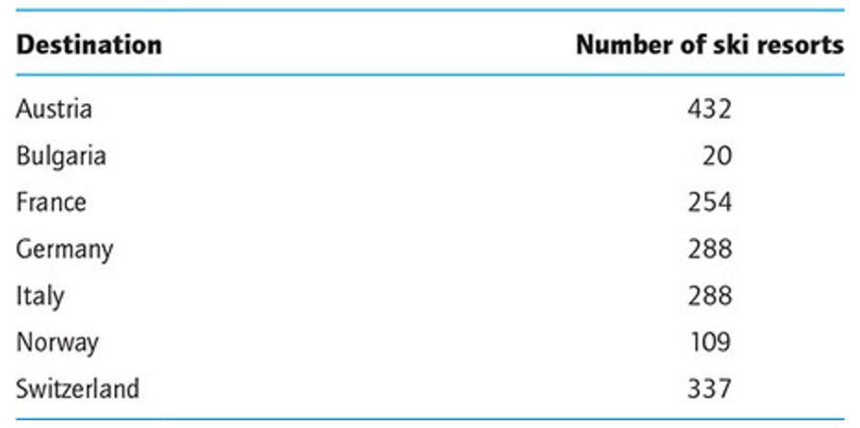
b) Pleases, find the descriptive statistics of the data set:
- mean,
- median,
- mode,
- range,
- interquartile range,
- extreme values,
- and standard deviation.

c) The researcher has sent 100 questionnaires and got 78 replies. What is the respondent rate?
In case of exams failure at the first session. The second variant of the test bank will be given.

6. Grading Scheme
Level | Mark | Description
Pass | 81%-100% | Excellent performance in course and class activities participation and interaction. Very good achievements in written and oral tests (ORAL: fluent in verbal interaction and response. WRITTEN: the answers were well–balanced. The majority of points was relevant and there was a clear link to the situation in the question).
Pass | 71%-80% | Good performance in course and class activities participation and interaction. Good achievements in written and oral tests (ORAL: ease in verbal interaction and response. WRITTEN: the answers were unbalanced. Most points were relevant to the situation in the question, but the link was not always clear).
Pass | 60 %-70% | Basic performance in course and class activities participation and interaction. Basic achievements in written and oral tests (ORAL: difficulty in verbal interaction and response. WRITTEN: just few key points identified, or one point superficially considered and not directly linked to the situation in the question).
Fail | Less than 60 points | No participation and interaction in course and class activities. No rewardable material. Student demonstrated an unsatisfactory quality of performance or standard of learning achievement.

Ivan Monich
March 02, 2020

